~~XML Exercises~~

~~For part1 and part2, first get the XML validation working with the DTD files given. Then write schemas to validate the documents. Because the XML files will differ, you should make two versions of the files. E.g.~~

~~DTD version:~~

* ~~Book.xml~~
* ~~Book.dtd~~

~~Schema version:~~

* ~~BookXS.xml~~
* ~~Book.xsd~~

~~(Hint: start with the XML Schema on slide 16 of the notes. You’ll have to modify this schema to suit the XML instance document)~~

~~You can install the XML extension from Red Hat in VSCode:~~

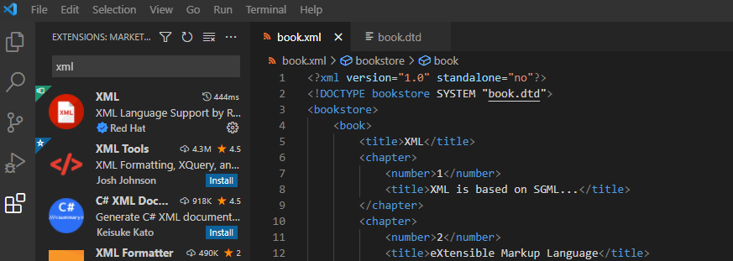

Note: use SHIFT–ALT–F to autoformat XML/XSD files

**~~Part 1:~~**

~~<?xml version="1.0" standalone="no"?>~~

**book.xml (DTD version)**

~~<!DOCTYPE bookstore SYSTEM~~ **~~"book.dtd"~~**~~>~~

~~<bookstore>~~

~~<book>~~

~~<title>XML</title>~~

~~<chapter>~~

**book.dtd**

<!ELEMENT bookstore ( book+ ) >

<!ELEMENT book ( title, chapter+, price ) >

<!ELEMENT chapter ( number, title ) >

<!ELEMENT title ( #PCDATA ) >

<!ELEMENT number ( #PCDATA ) >

<!ELEMENT price ( #PCDATA ) >

~~<number>1</number>~~

~~<title>XML is based on SGML...</title>~~

~~</chapter>~~

~~<chapter>~~

~~<number>2</number>~~

~~<title>eXtensible Markup Language</title>~~

~~</chapter>~~

~~<price>25.50</price>~~

~~</book>~~

~~<book>~~

~~<title>XHTML</title>~~

~~<chapter>~~

~~<number>1</number>~~

~~<title>XHTML is the successor to HTML...</title>~~

~~</chapter>~~

~~<chapter>~~

~~<number>2</number>~~

~~<title>HTML stands for HyperText Markup Language</title>~~

~~</chapter>~~

~~<price>35.99</price>~~

~~</book>~~

~~</bookstore>~~

**~~bookXS.xml (Schema version)~~**

~~<?xml version="1.0"?>~~

~~<bookstore~~ **~~xmlns="http://www.books.org"~~**

**~~xmlns:xsi="http://www.w3.org/2001/XMLSchema-instance"~~**

**~~xsi:schemaLocation="http://www.books.org book.xsd"~~**~~>~~

*~~<!—- The book elements are the exact same -->~~*

~~</bookstore>~~

**Part 2:**

~~<?xml version="1.0" encoding="UTF-8"?>~~

**laptop.xml (DTD version)**

~~<!DOCTYPE laptop SYSTEM "laptop.dtd">~~

~~<laptop>~~

~~<manufacturer>~~

**laptop.dtd**

<!ELEMENT laptop (manufacturer, model, memory, disk, screen, accessories+)>

<!ELEMENT manufacturer (name, country, continent)>

<!ELEMENT model (#PCDATA)>

<!ELEMENT memory (#PCDATA)>

<!ELEMENT disk (#PCDATA)>

<!ELEMENT screen (#PCDATA)>

<!ELEMENT accessories (#PCDATA)>

<!ELEMENT name (#PCDATA)>

<!ELEMENT country (#PCDATA)>

<!ELEMENT continent (#PCDATA)>

~~<name>Dell</name>~~

~~<country>Poland</country>~~

~~<continent>Europe</continent>~~

~~</manufacturer>~~

~~<model>Inspiron</model>~~

~~<memory>512M</memory>~~

~~<disk>60G</disk>~~

~~<screen>15inch</screen>~~

~~<accessories>Bag</accessories>~~

~~<accessories>Mouse</accessories>~~

~~</laptop>~~

**~~laptopXS.xml (Schema version)~~**

~~<?xml version="1.0"?>~~

~~<laptop xmlns="http://www.laptops.org"~~

~~xmlns:xsi="http://www.w3.org/2001/XMLSchema-instance"~~

~~xsi:schemaLocation="http://www.laptops.org laptop.xsd">~~

*~~<!—- The laptop elements are the exact same -->~~*

~~</laptop>~~

**~~Part 3:~~**

~~Write schemas (no need for DTDs) to validate the other files posted on Moodle:~~

* ~~Phonestore.xml~~
* ~~Showroom.xml~~